Pass Task 1 - Hello World

# Related Learning Outcomes

# ULO1 – Explain the OO Principles

This exercise demonstrated object encapsulation.

I learnt that a class is like an object’s blueprint, defining the properties and structure.

I learnt about constructor methods how they initialize the object when it is created.

# ULO2 – Use OO Language and Library

Demonstrated class and constructor declaration, the use of conditional statements (e.g. “if”), and assigning values to parameters. I learnt how to create a class, print a value from the class and enter a value for the class. The task used if statements to determine what values the user entered.

I learnt how to use a constructor method.

# ULO3 – Design, Develop and Test using an IDE

The code was developed using Xamarin Studio to build and run the program, as well as integrated debugging features to step and inspect values.

# ULO4 – Communicate using UML Diagrams

I learned how to interpret a UML class diagram and write the related code.

I understood how to convert a UML class diagram into variables, methods and functions.

Top part lists the class name, the middle part lists the data and the bottom part contains the methods.

# ULO5 – Describe Elements of Good OO Design

The exercise demonstrated correct use of C# coding conventions.

# Screenshots

[code running]

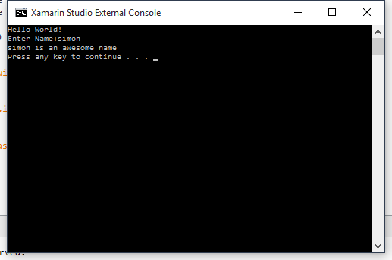

[use of IDE]

